**CVM GAP ANALYSIS DOCUMENT**

**I) AS-IS**

- Project’s name: CVM  
- Version: 1.0  
**1) Current Infrastructure**

- The 1.0 version has 4 elements: an UI web, a backend module, a Minio bucket server and a MariaDB server

**2) Current functionalities**  
2.1) Login, logout.  
2.2) User, Group and Permission management.

2.3) Fetching CV from 3rd parties.  
2.4) CV list management, CV detail viewing and changing status of a CV to Accept or Reject.

2.5) Dashboard.

**3) Limitations**

- Dashboard has only 2 charts: CV from 3rd parties diagram and CV status diagram, lacking many other necessary charts

- On the CV management page: the CV list is arranged in chronological order, CVs are easy to miss.

- On the CV detail page, users have to read manually, easy to miss information. Every time reading a CV, users spend a lot of time switching pages. There is no function to suggest CVs to other users

- Simple UI, not reasonable

- Sometimes there is a login failure error, sometimes there is an error requiring re-login

- Users cannot change their passwords

**II) TO-BE**

- Project’s name: CVM  
- Version: 2.0  
- Date: Dec 12th, 2024  
**1) Infrastructure**

- The 2.0 version has the same infrastructure with the 1.0 version

**2) New functionalities**

- The system can extract meaning from CV, such as: number of experience years, year of birth, skills, Gmail, containing FPT, Fsoft or Fis words or not…

- The system can automatically evaluate suitability of CV

- On the CV list management page, users can view and sort data by view count and matching percentage columns

- On the CV list management page, system will show warning if CV contains sensitive words: FPT, FIS, FSOFT

- On the CV detail page, users can suggest CV for other users

- On the CV detail page, users can put a CV to a blacklist

- On the CV detail page, users can put a CV to a blacklist

- On the Dashboard page, users can view percentage of CV status with a CV status pie diagram

- On the Dashboard page, users can view number of CV that applied to each hiring job diagram

- On the Dashboard page, users can view numbers of CV that has a specific skill by range of time diagram

- Users can schedule an interview and assign interviewers to interview candidates

- Users can note information during interviews about candidate and decide that candidate is pass or fail

- Users can manage result of interviews and change that result

- Users can schedule onboarding for candidates who passed interviews

- Users can config hiring job information and its criteria

- Users can subscribe to hiring jobs to receive notification about suitable CV

- The system will send notification to users about: scheduled interview, suitable CV and suggested CV

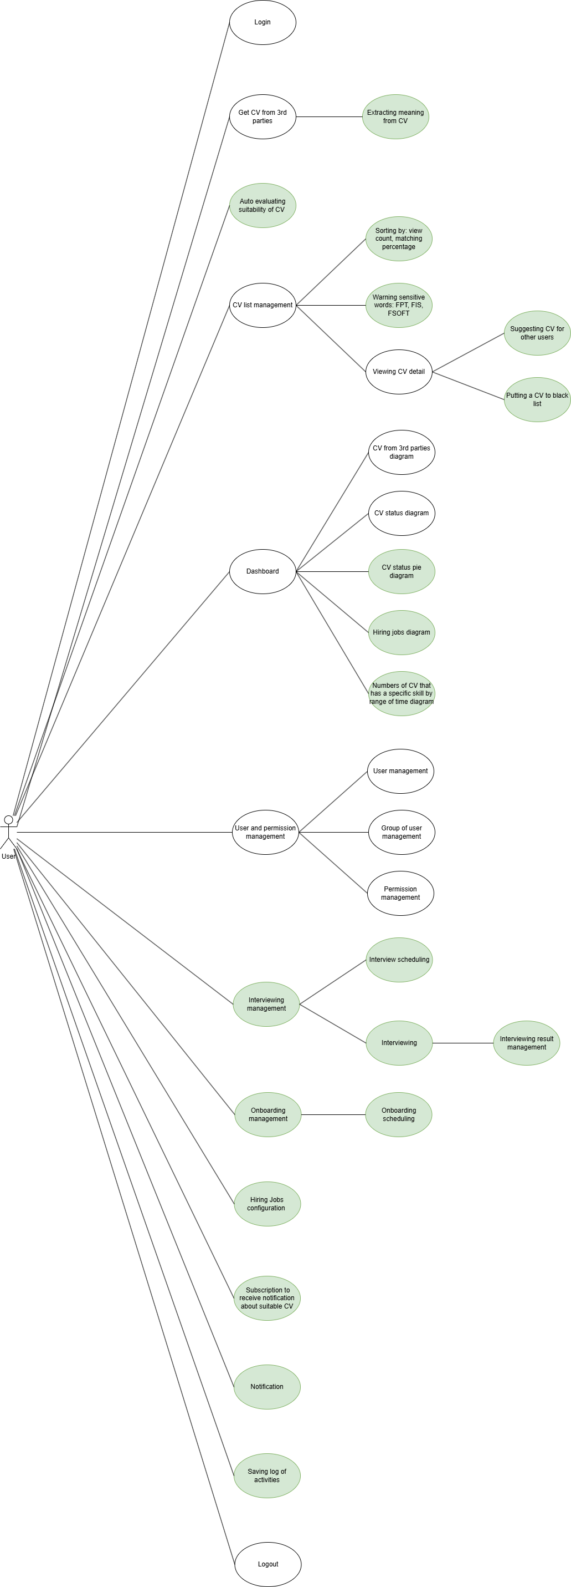

**III) Summary**

|  |  |  |  |  |  |  |  |  |
| --- | --- | --- | --- | --- | --- | --- | --- | --- |
| **No** | **Requirement Name** | **Level 1** | **Requirement** | **Current State (As-is)** | **Desired State (To-be)** | **Gap** | **Proposed Solution** | **Notes/Risks** |
| 1 | Authentication | Change password | Users can change password | N/A | Users can change password | There is no changing password feature yet | There will be a changing feature at the user profile page |  |
| 2 | Authentication | Logout | When users logout, the web page will call a refresh token api | N/A | When users logout, the web page calls a refresh token api | The 1.0 version does not call a refresh token api when users logout | the web page will call a refresh token api |  |
| 3 | Fetching CV and evaluate suitability of CV | Fetching CV from 3rd parties | The system fetch CV from 3rd parties every hour and extracting meaning from CV | The 1.0 system fetch CV from 3rd parties every hour | The system fetch CV from 3rd parties every hour and extracts meaning from CV and same it to database | The 1.0 version does not extract meaning from fetched CV | The system will extract meaning from CV using an algorithm | Some extracted meaning would not be correct like years of experience and education level |
| 4 | Automatically evaluate suitability of CV | The system can automatically evaluate suitability of CV | N/A | The system can automatically evaluate suitability of CV | There is no evaluating suitability of CV feature yet | - The system will allow users to define hiring jobs and their criteria - The system will compare extracted meaning from CV and define hiring jobs’ information to evaluate suitability of CV |  |
| 5 | CV management page | CV list page | The CV list page will display 2 more columns: view count and matching | N/A | Users can view the view count and percentage of suitability of CV and sort data on these columns | There is no view count and matching columns yet |  |  |
| 6 | The system will show warning if CV contains sensitive words: FIS and FSOFT | N/A | The system will show warning if CV contains sensitive words: FIS and FSOFT | The 1.0 version does not have this feature |  |  |
| 7 | Viewing CV detail | Users can suggest CV for other users | N/A | Users can suggest CV for other users | The 1.0 version does not have this feature |  |  |
| 8 | Users can put a CV to blacklist | N/A | Users can put a CV to blacklist | The 1.0 version does not have this feature |  |  |
| 9 | Users can view CV detail faster and identify current index of the CV | Users can not identify current index while view CV detail | Users can view CV faster and identify current index of the CV |  | Users can view CV detail using drawer |  |
| 10 | Interview scheduling | Interview scheduling | Users can schedule an interview and assign candidates and interviewer | N/A | Users can schedule an interview and assign candidates and interviewer | The 1.0 version does not have this feature |  |  |
| 11 | Evaluating candidates in interviews | Evaluating candidates in interviews | After an interview is scheduled, interviewer can use this system to evaluate candidate while interviewing them | N/A | After an interview is scheduled, interviewer can use this system to evaluate candidate while interviewing them | The 1.0 version does not have this feature |  |  |
| 12 | Users can view interviews’ result and change the result | N/A | Users can view interviews’ result and change the result | The 1.0 version does not have this feature |  |  |
| 13 | Onboarding management | Onboarding management | Users can schedule onboarding for candidates who passed interviews | N/A | Users can schedule onboarding for candidates who passed interviews and take note if needed | The 1.0 version does not have this feature |  |  |
| 14 | Hiring Jobs configuration | Hiring Jobs configuration | Users can configure hiring job and it’s criteria | N/A | Users can configure hiring job and it’s criteria | The 1.0 version does not have this feature |  |  |
| 15 | Subscription to receive notification about suitable CV | Subscription to receive notification about suitable CV | Users can subscribe hiring jobs to receive notification about suitable CV | N/A | Users can subscribe hiring jobs to receive notification about suitable CV | The 1.0 version does not have this feature |  |  |
| 16 | Notification | Notification | Users can receive notification about: scheduled interview, suitable CV and suggested CV | N/A | Users can receive notification about: scheduled interview, suitable CV and suggested CV | The 1.0 version does not have this feature |  |  |
| 17 | Dashboard | Dashboard | Users can view CV status pie diagram | Dashboard has only 2 charts: CV from 3rd parties diagram and CV status diagram | Users can view CV status pie diagram | The 1.0 version does not have this feature |  |  |
| 18 | Users can view hiring jobs diagram | Users can view hiring jobs diagram and filter by date range | The 1.0 version does not have this feature |  |  |
| 19 | Users can view common skills diagram by date range | Users can view common skills diagram by date range | The 1.0 version does not have this feature |  |  |
| 20 | Logging | Logging | The system will save log of activities | N/A | The system will save log of activities, such as: viewing detail log | The 1.0 version does not have this feature |  |  |